Table of Contents for Software Planning Document

3. Software Planning Document 38
3.1. Introduction 38
3.1.1. Project Overview 38
3.1.1.1. Purpose of this Plan 38
3.1.1.2. Major Functions 38
3.1.1.3. Performance Issues 38
3.1.2. Project Deliverables 38
3.1.3. Evolution of the GPSP 38
3.1.4. Reference Materials 39
3.1.5. Definitions and Acronyms 39
3.2. Project Organization 39
3.2.1. Process Model 39
3.2.2. Organizational Structure 40
3.2.3. Organizational Boundaries and Interfaces 40
3.2.4. Project Responsibilities 41
3.3. Managerial Process 41
3.3.1. Management Objectives and Priorities 41
3.3.2. Assumptions, Dependencies, and Constraints 41
3.3.3. Risk Management 41
3.3.3.1. Introduction 41
3.3.3.2. Risk Factors 42
3.3.3.3. Analysis of High-Impact Risk Factors 43
3.3.4. Monitoring and Controlling Mechanisms 45
3.3.4.1. Tracking and Control Mechanisms 45
3.3.4.1.1. Reliability 45
3.3.4.1.2. Availability 45
3.3.4.1.3. Maintainability 46
3.3.4.1.4. Security 46
3.3.5. Staffing Plan 46
3.3.5.1. Overall Approach 46
3.3.5.2. General Duties 46
3.4. Technical Process 47
3.4.1. Methods, Tools, and Techniques 47
3.4.1.1. Technical Process 47
3.4.1.1.1. Technical Review 47
3.4.1.2. Testing Process 47
3.4.1.2.1. Unit Testing 47
3.4.1.2.2. Integration Testing 48
3.4.1.2.3. System Testing 48
3.4.2. Software Documentation 48
3.4.3. Project Support Functions 48
3.5. Work Packages, Schedule and Budget 48
3.5.1. COCOMO overview 48
3.5.1.1. COCOMO II Scale Factors 49
3.5.1.2. COCOMO II Function Points 49
3.5.2. Work Packages 51
3.5.3. Resource Requirements 51
3.5.3.1. Team Members 51
3.5.3.2. Hardware 51
3.5.3.3. Software 52
3.5.4. Budget and Resource Allocation 53
3.5.5. Schedule 55
3.5.5.1. Project Schedule 55
3.6. Index 57

3. Software Planning Document

3.1. Introduction

3.1.1. Project Overview

The purpose of this document is to provide a reference guide for the efficient production of the GPSP software package.

3.1.1.1. Purpose of this Plan

This plan analyzes the risks, costs, and time schedules for the completion of the GPSP software package. This document identifies all elements that need to be monitored to ensure a satisfactory completion in a timely manner. It identifies and manages the required resources, risks, cost estimates, and quality control implementations, as well as provides a summary of the overall development of the GPSP system. Also, it provides a timeline to follow in order to ensure completion of the entire project.

3.1.1.2. Major Functions

See section 5.1.2 for a detailed explanation of the function points used.

3.1.1.3. Performance Issues

The GPSP system will experience a predictable workload. As only 3 pumps can be activated at one time, the system need only be able to handle the operation of 3 pumps simultaneously. Other functions the GPSP package will provide, such as communications and customer check-out, will have little to no impact on the system workload. Accesses to the database will be simple and short. In fact, the only database that will increase in size will be the consumable items database, and its growth is not expected to be large or abrupt. Thus the GPSP system will, under all likely situations, not require hardware renewal. However, if system performance does become an issue, hardware upgrading will be necessary.

3.1.2. Project Deliverables

Project delivery will be initiated at the required due date.

3.1.3. Evolution of the GPSP

This document will be updated whenever a change is made to the GPSP system. Any one member of the software development team will be capable of updating
this document, following the standards and guidelines set forth in IEEE std. 1038.1-1987 by the IEEE standard committee.

3.1.4. Reference Materials

1. IEEE (1016-1987) Recommended Practice for Software Design Document, Sponsored by Software Engineering Standards Committee.

2. Software Engineering 6th Edition by Ian Sommerville.

3.1.5. Definitions and Acronyms

Client – Person who pumps the gas into their vehicle and is the end user for the client interface.

Clerk – Person who is actively currently standing at the Gas Station’s register. They interface with the Clerk administrative software portion of the GPSP.

Database – A central data receptacle that stores all information about sales of gasoline from each gasoline distribution center.

Distribution Center – Gasoline station responsible for selling and distributing gasoline.

Employee – This is a person in charge of operating the gas station. It can refer to either a manager or a clerk.

GPSP Application - The software package that offers database software, report generation functionality and an end user interface.

Manager – Person who is in charge of the gas station. They will have access to the Managerial software portion of the GPSP package.

Report Generator – Interfaces with the centralized database and correlates data into a useful form in order to supply information useful in decision making.

User – Anyone who uses the GPSP package who is not a customer.

3.2. Project Organization

3.2.1. Process Model

The software development team for the development of the GPSP software package shall incorporate the use of the classic waterfall development model. This approach will allow the team to divide the project into separate phases of development. To estimate the costs of this project, we will be using the COCOMO II model of cost estimation.

3.2.2. Organizational Structure

A team of closely-knit group members will create the GPSP software package. Each group member will be assigned primary roles, but each member should be fairly capable of operating under any assigned role. Such roles will consist of: code implementation, documentation, GUI interface creation, and quality of assurance. Decisions and overall management for the GPSP team will be made in an informal interpersonal manner, and thus no group member will necessarily have precedence over or outrank another member. Each member of the group will communicate with each other, providing input, review, compliments, and constructive criticism to each other. A representative will be chosen by the team to talk with both the GPSP software development teams upper management and the company purchasing the GPSP package. The role of the elected representative will be chosen based on a group consensus and can change as the group sees fit. The organizational structure is depicted in figure 3.2.2.1.

Upper Management
Elected Representative
Group Member 1
Group Member 2
Group Member 3
Group Member 4
Team
Communication
Purchasing Company
Elected Representative

Figure 3.2.2.1 Team Organizational Structure

3.2.3. Organizational Boundaries and Interfaces

The GPSP software development team will coordinate with each other on project progression at least twice a week. This will allow for significant communication, corroboration, and planning, ensuring the projects completion at the determined deadline and quality of assurance. Assignment of roles and tasks to be done by each group member will be arbitrarily decided at these meetings, depending on what tasks need to be done and the timeframe in which they need to be done. If a particular task is required to be done with much brevity, then multiple group members may be assigned to that task.

3.2.4. Project Responsibilities

The completeness and accuracy of the project document is responsibility of each team and ever team member. Participation of each member will obviously be necessary. These responsibilities include the following:

- Group corroboration on what assignments each member will have
- Editing a proofreading any work done
- Creation and review of diagrams, charts, tables, and other support material
- Submitting the document and/or code by the set deadline
- Make changes in previously written documents and code when necessary

3.3. Managerial Process

3.3.1. Management Objectives and Priorities

The highest priority for the GPSP software package is that it meets the requirements set forth in the SRS. The second highest priority is to meet the scheduled deadlines. Lastly, the third highest priority is to stay within the limitations of the budget.

3.3.2. Assumptions, Dependencies, and Constraints

There are no known external or internal issues or events that may impact the creation of the GPSP software package. However, this does not rule out the possibility of an untimely incident that may halt or hinder the project’s progression. A list of possible events or issues that may arise throughout the duration of the GPSP software development is further detailed in section 3.3.3.2.

3.3.3. Risk Management

3.3.3.1. Introduction

This section is intended to deal with those unexpected factors that may have an adverse impact on the outcome of the GPSP project. Individual factors have been identified and enumerated, and for each, an effort has been put forth to estimate the likelihood that the event will occur, and to assess the degree of negative impact the event would have on the outcome of the project. Probabilities have been assigned in five categories, which are:

Rating | Likelihood
Very Low | Less than 10% chance
Low | 10% to 25% chance
Moderate | 25% to 50% chance
High | 50% to 75% chance
Very High | Greater than 75% chance

The degrees of impact of the possible adverse events have been assigned as follows:

Rating | Effect
Devastating | Successful completion of the project is impossible
Serious | Successful completion of the project is possible, but unlikely
Tolerable | Completion of the project will occur, but more effort will be required
Insignificant | The adverse event can be dealt with relatively little additional effort

The GPSP software package will be run using very well tested, and moreover tried and true technologies. That is, PHP, MySQL, and web browser technologies are very well tested and established. One very prominent positive factor in the GPSP system is that it will not require any hardware upgrades. In addition, the team is experienced and seasoned, with one member in particular who has completed a very similar project. Thus, whereas risk factors are always at play, the most catastrophic factors will be highly unlikely.

3.3.3.2. Risk Factors

This section details all identified risks and their probabilities and estimated impacts. See the figure below:

Risk | Probability | Impact
Cancellation of project by management | Low | Devastating
The business purchasing the GPSP goes bankrupt | Low | Devastating
Loss of team member | Low | Serious
System size underestimated | Low | Serious
Speed performance of program is unacceptable | Low | Serious
Late delivery | Low | Serious
Budget Overrun | Low | Serious
Technology obsolete | Low | Mild
Inadequate Testing | Moderate | Mild
Staff temporarily unavailable | Moderate | Tolerable
Change of superior company management | Low | Insignificant
Small change in SRS | Mild | Tolerable
Large change in SRS | Low | Serious
Programming workbench server unavailable | Low | Serious

3.3.3.3. Analysis of High-Impact Risk Factors

Those factors that have a high potential for a devastating or serious impact are examined in this section in greater detail. Suggested actions are also made for each of these cases that will help deter these events from occurring or at least lesson their impact on the outcome of the project.

Cancellation of the project by management
The organization that manages the GPSP software team may decide to cut the project. If this I the case, basically the entire project and team will be dissolved. This will be very unlikely, but it cannot be ruled out.

System size underestimated
The system requirements for the GPSP software package are very low, on the server and the client side. As a result, this case is exceedingly unlikely. The amount of processor power and storage space required by the GPSP is so insignificant, that many machines that are 5-10 years old will be fully capable of running the software. However, as a safeguard, the size and the amount of CPU cycles the GPSP software package uses will be monitored regularly in the case of any unforeseen occurrences.

Loss of a team member
The case of a lost team member in an already small team (4 people) would result in a substantial workload increase for the remaining group members. While the project could still be completed, it may lack the quality it would have had with a complete team. Additionally, the project may not be able to be completed at the scheduled deadline.

The business purchasing the GPSP system goes bankrupt
If the business or company that is intending to purchase the GPSP system has gone bankrupt, the future of the GPSP package may be void. However, it may also be the case that another buyer will purchase the software in lieu of the original purchasing company. However, if the original buyer cannot proceed with the payment for the software package, and no other buyers can be found, the GPSP project will likely be terminated.

Hardware Unavailable
The hardware required for this project is very simple. Virtually any desktop PC will be able to act as a console for clerks and managers. However, a dedicated server will be required to host the project’s web server. If no dedicated server can be allocated, the GPSP package will not be capable of running. Fortunately, because of the low hardware requirements the GPSP requires, any cheap, but reliable, server will suffice to host the GPSP web server.

Speed performance of the GPSP is unacceptable
The amount of work the GPSP software does is very simple. Thus, speed should never be an issue. However, as a safeguard, the team will be monitoring the speed and reaction time of the GPSP package on a regular basis, in addition to stress testing the server for the maximum load of users. This will ensure that the GPSP package will run at acceptable speeds under all perceivable circumstances.

Late delivery
Late delivery of the program would be an embarrassment to the programming team, as well as to the team’s management. Every team member will and has put in enough effort to ensure that the project will not be late.

Budget overrun
In an effort to avoid the looming issue of budget, we have looked to the COCOMO 2 tool to arrive at the best possible budget estimate for the GPSP package. We have given a reasonable margin of error in our estimates, and we feel confident that our project will not overrun the budget.

Large change in the SRS
If the requirements for the program are changed on a large scale, the effects of this could be very drastic. Entire sections of the program may need to be scratched, re-written, and new code will likely need to be written. This would take a very large amount of time and cost undoubtedly. To help curb the effects, if this event were to transpire, our team has attempted to modularize our code as best we can. This would, hopefully, allow for easy addition of new code and replacement, modification, or removal of unneeded or unwanted code.

Programming workbench unavailable
If the server our team is using to create and compile code on is unavailable, progress of the project will be virtually halted. Thus, in an attempt to avoid this, the server has been set up to run FreeBSD—a very stable operating system. In addition, the system has been shielded with a surge protector and back-up power device. To further security, all code and documentation is backed up on a daily basis to avoid losing data.

3.3.4. Monitoring and Controlling Mechanisms

3.3.4.1. Tracking and Control Mechanisms

This section details the tracking and control mechanisms used in developing the GPSP as an efficient, accurate system that meets the system and user specifications. It elaborates upon the required features of the GPSP.

3.3.4.1.1. Reliability

Reliability is essential attribute of the GPSP. The system should run without failure. To ensure this, the reliability of the system will be measured by an error rate. For every 10,000 operations performed, the GPSP will fail no more than once—an error rate of 0.001. To achieve this system reliability of the GPSP, the following objectives will be met:

- The operating system will be upheld with the latest updates
- The PHP platform will be upheld with the latest updates
- The program code will be reviewed during the design phases and each consequent implementation of GPSP
- The program code will include exception and login handling
- User-inputs will be validated for the clerk and manager systems
- User-inputs’ format will be checked and validated
- Some user-inputs will be list boxes, combo boxes, radio buttons, and other error reduction GUI components
- Feedback will be provided by the system to the user if inputs are invalid in the form of error messages

3.3.4.1.2. Availability

The GPSP package will be available 24-hours a day to accommodate the need for customers who need gas at any hour of the day. To accomplish this, the system will need to be fully functional at all times. The system will be backed up daily, in the event that the system goes down, so the time required getting the system back up and running will be minimal. All in all, the GPSP system must be available 99.999% of its running time.

3.3.4.1.3. Maintainability

The GPSP system must be maintained in order to accommodate for future changes. Such changes could include adding the ability to run more than 3 pumps at once or adding more types of gasoline selections to the system. The code for the GPSP will be developed using the following guidelines to promote system maintainability:

- Code will be modularized for easy reading
- Code will contain straightforward, descriptive comments
- Code will not be compacted and unreadable

3.3.4.1.4. Security

Security of the GPSP system is an absolute essential in today’s world. Because of increasing gasoline prices, customer drive-offs have been an increasing problem. As a result, the GPSP system will have a prepay policy, so no gas will be able to be pumped until it has been paid for. The following standards will be adhered to in order to provide the highest level of security for the GPSP.

- The system will run in a private business environment
- User login information will be necessary for both clerks and managers
- User login names and passwords will be encrypted
- System will be password locked when user steps away from the system
- All password entry text fields will be “starred out”
- Customers will be required to prepay for all gasoline

3.3.5. Staffing Plan

3.3.5.1. Overall Approach

The structure of this project team is entirely democratic. All decisions are made through a group consensus. Thus, every team member has a say in how or what is done. These decisions will be made at the weekly group meetings. If more meetings are required, extra meeting dates will be held as necessary.

3.3.5.2. General Duties

For our group, Nathan will have the primary role as our programming, as he knows PHP more than the rest of us. He shall write most of the code, comment it, and explain to the rest of the team how it works. Phil will be our primary technical writer. He will oversee the creation of every document, and he will decide on the format, wording, etc for each document produced. Kevin and Matt will both be veritable “jack of all trades.” They will help Nathan with the programming, as well as help Phil with the documentation process, e.g. writing, organizing, and proofreading. It can be said that all group members will put in an equal amount of work and effort.

3.4. Technical Process

3.4.1. Methods, Tools, and Techniques

3.4.1.1. Technical Process

This section describes the technical aspects of the GPSP included in the
Software Specification Requirements document. This section provides the guidelines for the design team to implement the software.

3.4.1.1.1. Technical Review

During review, the software will be evaluated based on the Software Requirements and Design Document. The code will be reviewed after each phase by the members of the programming team, as well as by the technical advisor. Any changes made at this time will be a collaborative decision.

3.4.1.2. Testing Process

This section elaborates upon the various testing phases of the GPSP. These phases are in place to assure that all requirements are met for the software.

3.4.1.2.1. Unit Testing

Each separate application of the GPSP will be tested independently. This will occur whenever an individual unit is completed, or changes are made to a previously completed unit. The testing will ensure that the software maintains all requirements set forth in the Software Requirements Specifications. Data will be entered to ensure proper linking of the databases. Incorrect data will also be input to ensure proper error checking and security. Once each unit is testing properly, the next phase of testing may begin.

3.4.1.2.2. Integration Testing

The individual units of the GPSP will then be integrated together. This integrated software will be tested for proper performance. The integration will be done one unit at a time, to ensure that each unit relates to the others properly. Whenever there is an error, the units will be separated once again and the error will be analyzed and fixed. Once all units are integrated and running properly, the final testing phase may begin.

3.4.1.2.3. System Testing

The final stage of testing will test the system as a whole. A variety of simulated transactions will occur. This will test the overall performance of the system, when related to real-life conditions. Any errors found shall be analyzed and testing will backtrack to the necessary step in order to fix the problem. Once this phase of testing is completed, the system should be running exactly as stated in the Requirement and System Specifications.

3.4.2. Software Documentation

The Software Documentation will be written to comply with the standards of the IEEE Std. 829-1983.

3.4.3. Project Support Functions

A technical support advisor will be on hand in case of any problems.

3.5. Work Packages, Schedule and Budget

3.5.1. COCOMO overview

The project estimates are computed using the Costar 7.0 project estimation tool that utilizes the COCOMO II model of project estimation. The figure below displays the final result. In summary, the project is estimated to take 6.1 person months or 7.4 calendar months to be completed. Cost estimate for the entire project is $21,300. Approximately 3800 lines of code will be delivered, and a total of 4370 lines will be created overall. The following sections will enumerate the factors taken into consideration to arrive at this estimate.

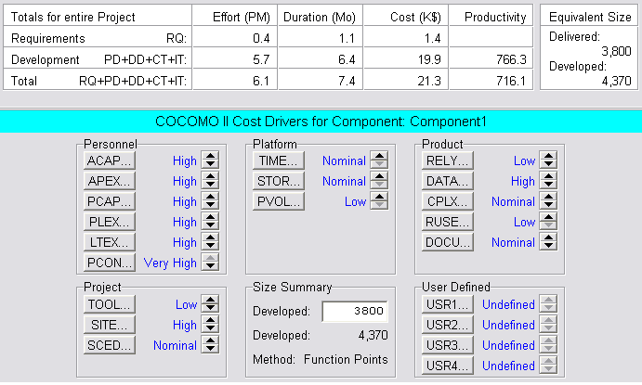
Figure 6.1 COCOMO Summary

3.5.1.1. COCOMO II Scale Factors

The COCOMO II Scale Factors displayed in Figure 6.1 were chosen as follows:

- Precedentedness: Generally Familiar because of the existence of several similar systems in place throughout the world. Our programmers are familiar with similar applications from other projects.
- Development Flexibility: General Conformity due to the software needing to meet certain System Requirements, yet aesthetically speaking, the programmers have open freedom.
- Architecture / Risk Resolution: Some ( 40% ) because some basic risks due arise, but they are neither lethal nor hard to fix.
- Team Cohesion: Basically Cooperative because our team interacts nicely, however there are slight scheduling issues involved in planning meetings.
- Process Maturity: Level 2 as we have not yet worked in a team together, but do seem to relate well and handle the project cooperatively.

3.5.1.2. COCOMO II Function Points

The COCOMO II Model that we chose uses function points to estimate the size of the project. The functions points are listed below.

External Inputs, 6 function points ( 3 simple, 3 average)
- Login Information (simple)
- Gas type selection (simple)
- Fuel begin (simple)
- Sale information (average)
- Add item to database (average)
- Order more gas (average)

External Outputs, 3 function points ( 2 simple, 1 complex)
- Total of transaction (simple)
- Amount of gas pumped (simple)
- Manager sales report (complex)

Logical Internal Files, 4 function points ( 1 simple, 3 complex)
- Database for employee login (simple)
- Database for product information (average)
- Database for gas sales/transactions (average)
- Database for other goods sales (average)

External Interface Files, 0 function points
External Inquiry, 1 function point ( 1 simple )
- Requests to database for information (simple)

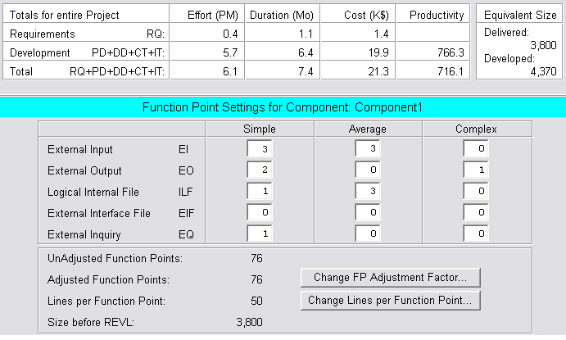
Figure 6.1.2 COCOMO II Function Points

3.5.2. Work Packages

For the GPSP to be completed, the following steps must be followed:

- Create Project Team: Team members must be assigned who have the skills necessary to complete the project.
- System Definition Document: The basic functions, constraints, and assumptions are defined in this document. It elaborates on how the customer and project team will communicate.
- Software Requirements Specification: This document will describe in greater detail what the system is required to do.
- Project Planning Document: The costs, risks, time requirements, and resources of the project are detailed in this document. It also will describe management of the available resources.
- System Documentation: The documentation will include a user’s manual, a system manual, and documentation of source code. It will provide instructions for any user to operate the system properly, and provide information on the structure of the system.
- System Delivery: In order for this stage to take place, all testing must be complete, as well as all documentation. Once this stage is met, a fully functional version of the system will be available for the customer.

3.5.3. Resource Requirements

3.5.3.1. Team Members

For a project of this size, team members of the necessary level will be required. This means that the members must be able to do their assigned work in the allowed amount of time to prevent the project from being completed late. The project has been divided up among the team members, with each member focusing on one particular aspect of the problem. However, if any member of the team falls behind schedule, the remaining workload of that member is divided among the rest of the team to ensure deadlines are met. Also, if any member has a problem, the remaining members will be free to help until the problem is solved.

3.5.3.2. Hardware

For this project, a desktop PC will be needed by each of the team members to complete their assignments. The minimum requirements for each individual PC are as follows:

- 1 GHz or faster processor
- 256 MB or more RAM
- Portable Media (i.e. floppy disc, CD-RW, etc.)
- Internet Access (for communication)

3.5.3.3. Software

The software packages that are required for each member to complete their responsibilities on time are as follows:

- Windows Operating System
- Microsoft Office (for documentation)
- PHP / PERL (for coding)

The project requires the following types of staff and their relative cost per person-month.

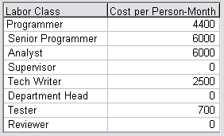
Figure 6.3.1 Labor Costs Worksheet

The following form illustrates the percentage of responsibility per stage for each category of staff.

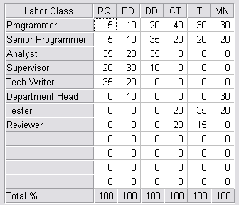
Figure 6.3.2 Labor Distribution

3.5.4. Budget and Resource Allocation

The cost of each iteration is detailed in the following figure.

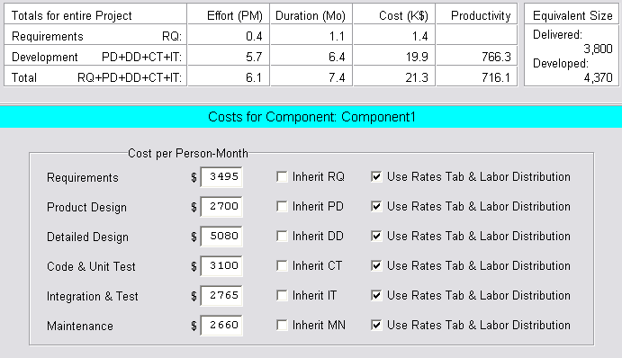
Figure 6.4.1 Labor Costs

The cost drivers for the estimate are shown in the following figure.
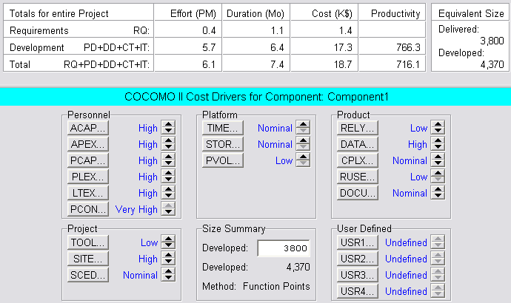
Figure 6.4.2 Cost Drivers

The following information explains our reasoning for the level of each factor.
Product
RELY – Required Software Reliability: Low. There should be no reason for risk of life in case of a software error.
DATA – Database Size: High. As the amount of data in the database increases, this driver rises. The amount of data in a database can grow constantly with new items, high was the best option.
CPLX – Product Complexity: Nominal. The product is not mission critical, but there is a small level of complexity involved.
RUSE – Required Reusability: Low. Code may be reused, but only within the project itself.
DOCU – Documentation: Nominal. Documentation is appropriate to life cycle.

Platform
TIME – Execution Time Constraint: Nominal. Less than 50% of CPU time will be used.
STOR – Main Storage Constraint: Nominal. Less than 50% of main storage will be used.
PVOL – Platform Volatility: Low. Major changes will seldom occur.

Personnel
ACAP – Analyst Capability: High. The analyst team is of better than average.
APEX – Applications Experience: High. The team averages 3 years of programming.
PCAP – Programmer Capability: High. The team is highly trained in programming. Each member also has special training in certain departments.
PLEX – Platform Experience: High. The team averages 3 years of experience.
LTEX – Language and Tool experience: High. The team averages 3 years experience with the tools needed to complete the project.
PCON – Personnel Continuity: Very High. There is little or no turnover in the team.

Project
TOOL – Use of Software Tools: Low. There is a minimal use of CASE tools.
SITE – Multi-site Development: High. The development occurs in separate buildings of the same city.
SCED – Development Schedule: Nominal. No acceleration or lengthening is necessary.

3.5.5. Schedule

3.5.5.1. Project Schedule

The deliverables of the fuel company and their completion dates are:

- System Definition – February 18, 2004
- Software Requirements Specification – March 8, 2004
- Project Plan – March 31, 2004
- Design Document – April 12, 2004
- Object Oriented Analysis – April 19, 2004
- Tested and Debugged Program – April 26, 2004
- User’s Manual – April 26, 2004
- Project Legacy – April 26, 2004

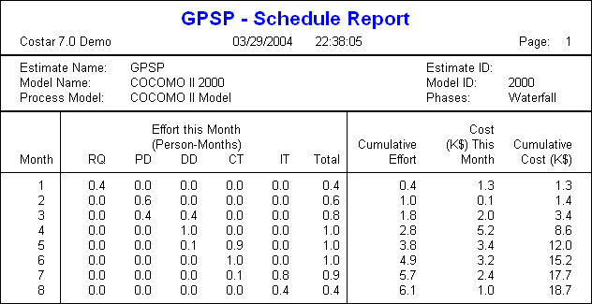
Figure 6.5.1 Project Schedule Report

3.6. Index

C
Clerk 39
Client 39
COCOMO II model 48
COCOMO overview 48
Cost Drivers 54

D
Database 39
Development Flexibility 49
Distribution Center 39

E
Employee 39
External Inputs 50
External Inquiry 50
External Interface Files 50
External Outputs 50

G
Gasoline station 39
GPSP Application 39

I
Integration Testing 48

L
Labor Costs 53
Labor Costs Worksheet 52
Labor Distribution 53
Logical Internal Files 50

M
Manager 39
Methods, Tools, and Techniques 47

P
Precedentedness 49
Project Schedule 55
Project Schedule Report 56
Project Support Functions 48

R
Report Generator 39
Resource Requirements 51

S
Scale Factors 49
Software Documentation 48
System Testing 48

T
Team Organizational Structure 40
Technical Process 47
Technical Review 47
Testing Process 47

U
Unit Testing 47
User 39

W
Work Packages 51
Work Packages, Schedule and Budget 48

